Super Quiz Night
In aid of the
Barbados Tennis Association
On
Friday 9th March, 2007
At
The Barbados Yacht Club
From 7pm

Proceeds to help send players to Fed Cup & Davis Cup Tournaments

Fun for All!!

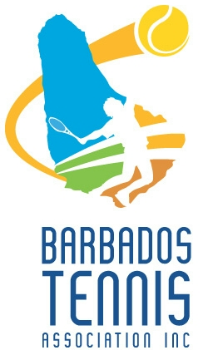

Tables of 10 at $100 per person
(Children 14 and under – free)
Light refreshments & drinks included

Tickets are available from Patricia at 268-6295,
Ellie 428-6749, Helen at 423-1272, or
e-mail tennisbarbados@sunbeach.net

